|  |  |
| --- | --- |
| **Operating Systems & Networking Fundamentals**  Diploma in CSF/IT  Year 1 (2021/22) Semester 2 | Week **4** |
| **30 mins** |
| **Monitoring Memory Usage using Resource Monitor** | |

**Objective**

At the end of the practical, students should be able to monitor memory performance and usage using Resource Monitor utility in Windows.

**Introduction**

Resource Monitor displays information about the use of hardware (CPU, memory, disk, and network) and software (file handles and modules) resources in real time.).

**Activities**

1. Type “resmon” in Windows Search Box to open Windows Resource Monitor. Click on the Memory tab to access the memory information page as shown in the screen shot below.

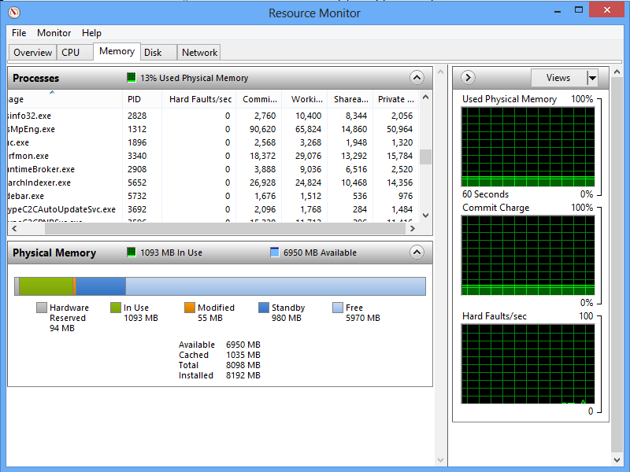

Mouse over each of the following headings in the Process pane and copy the screen tips that appear into the table below.

|  |  |
| --- | --- |
| **Heading** | **Screen Tip (Explanation of Heading)** |
| Image | Image: Process executable file name |
| PID | PID: Process ID |
| Hard Faults / sec | Hard Faults/ sec: Average number of hard page faults per second in the last minutes |
| Commit | Commit (KB): Amount of virtual memory reserved by the operating system for the process in KB |
| Working Set | Working Set (KB): Amount of physical memory currently in use by the process in KB |

1. Figure 2 below is a screen shot of the Resource Monitor showing the Physical Memory usage of a laptop in the form of a horizontal bar (bottom panel). By studying the numbers below the horizontal bar, answer the following questions based on the information displayed in the figure.

[Note: You will be able to see clearer the colours in the horizontal bar if you view the softcopy of this worksheet. Also, there are on-screen explanations if you mouse over the bar or the legend below it in an actual *Resource Monitor* window. You may wish to run this tool while answering the questions.]

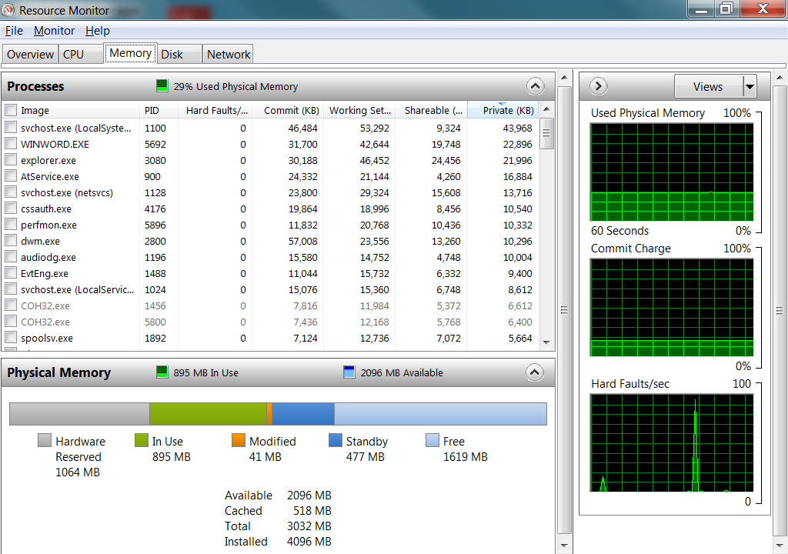

Figure 2 – Screen shot of Resource Monitor displaying the Physical Memory Usage

* + 1. How much RAM was installed in the laptop?

4096 MB of RAM was installed in the laptop.

* + 1. “Available” referred to the amount of memory that was immediately available for processes to use. What was it comprised of?
    2. The memory that is free and that is on standby.
    3. “Total” was stated as 3032 MB. What did this total refer to?

The total RAM available excluding the RAM used for the hardware reserved. It is the sum of the RAM in Use, Modified, Standby and Free.

______________________________________________________________

-- The End --